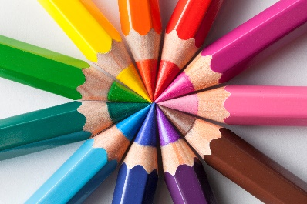

**School Supply List**

Pencils

1 pack of crayons

1 pack of colored pencils

1 pack of markers

3 2-pocket folders

2 pairs of scissors

Tissues

Clorox wipes

Bottle of hand sanitizer